NAME: Sharvayu Zade
PRN: 23070521135
SEC: B(B2)

Part 2 – Error Handling & Reverse Number Palindrome Problem
1. Error Handling with try...catch
Definition:
The try...catch statement is used to handle runtime errors so your program doesn’t crash. ● try block → Contains code that might throw an error.
● catch block → Runs only if an error occurs in the try block. The error details are stored in the error object.
Syntax:
try
{
// code that may throw error
}
catch (error)
{
// handle error
}
Example 1 – Division by Zero
try
{
let result = 10 / 0;
if (!isFinite(result)) throw new Error("Cannot divide by zero!");
console.log(result);
}
catch (err) {
console.log("Error:", err.message);
}
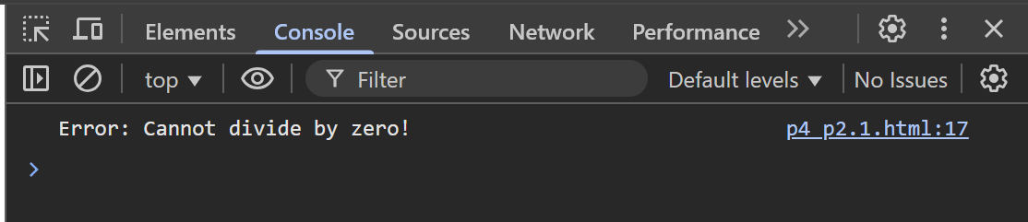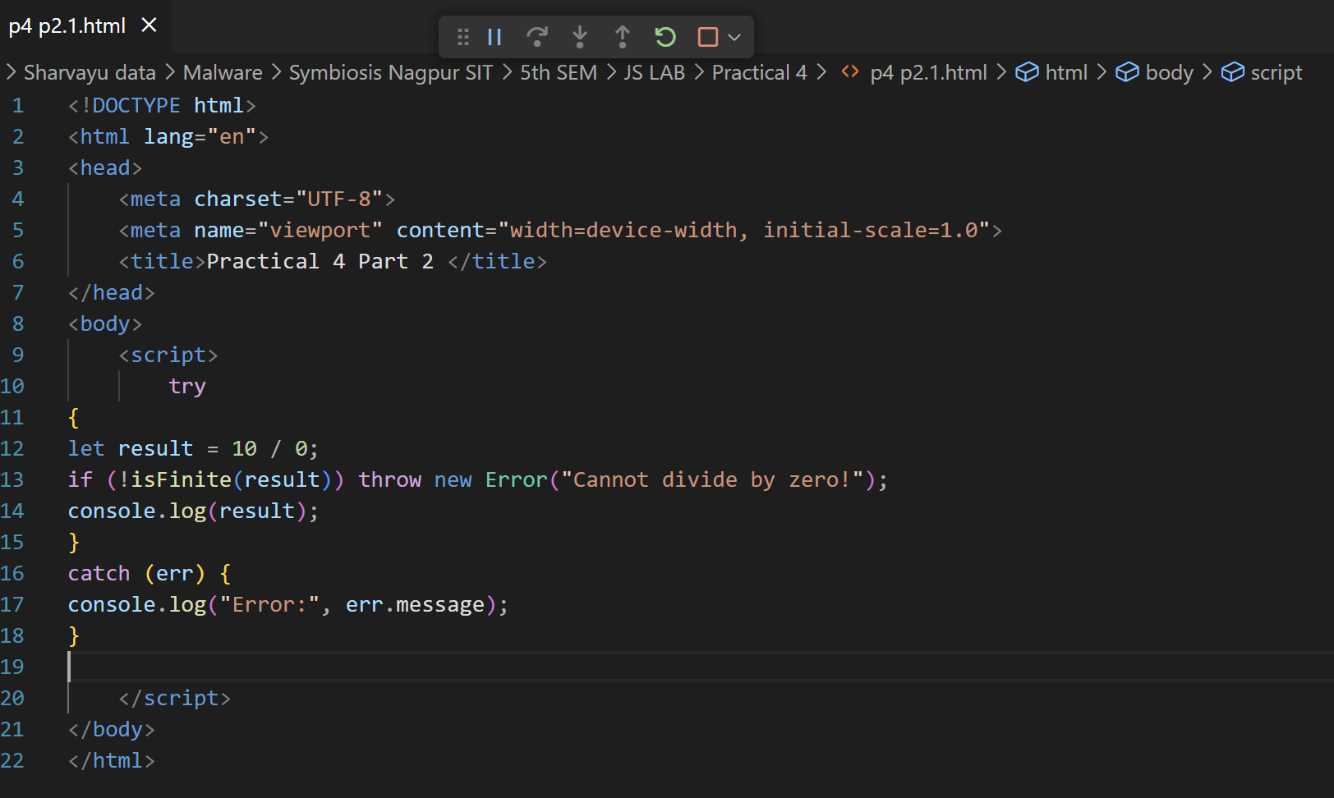
Example 2 – Invalid JSON
try
{
let data = JSON.parse("invalid json");
}
catch (err)
{
console.log("JSON Parse Error:", err.message); } 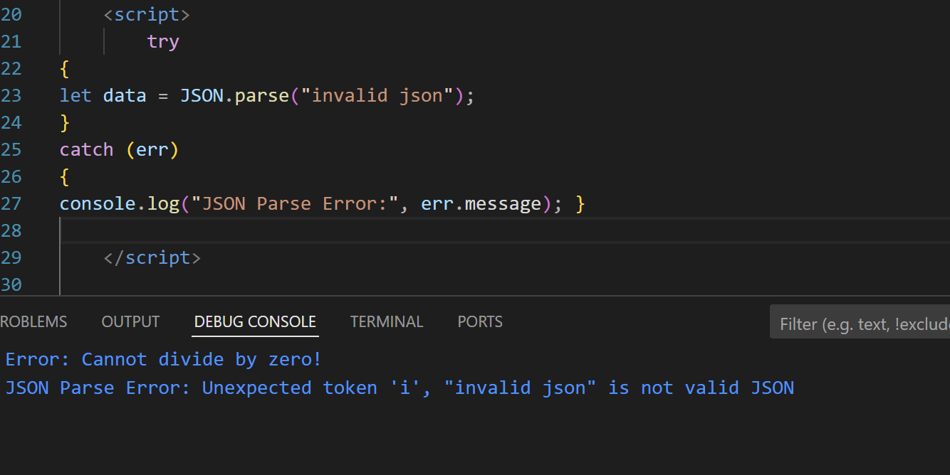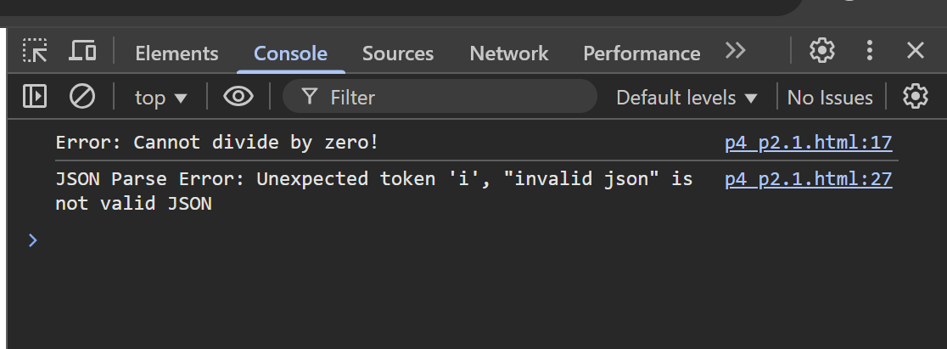
Example 3 – Manual Error Throwing
function checkAge(age)
{
if (age < 18) throw new Error("You must be 18+"); return "Access granted";
}
try
{
console.log(checkAge(16));
}
catch (err)
{
console.log(err.message);
} 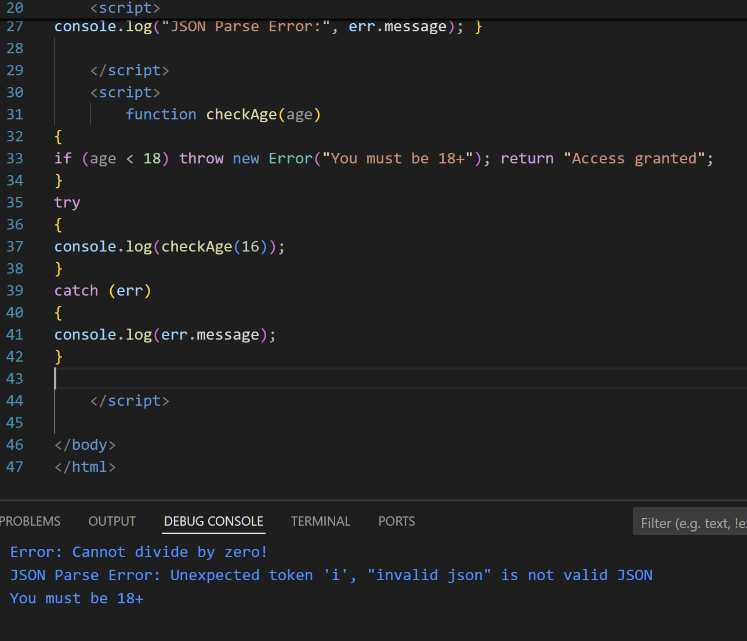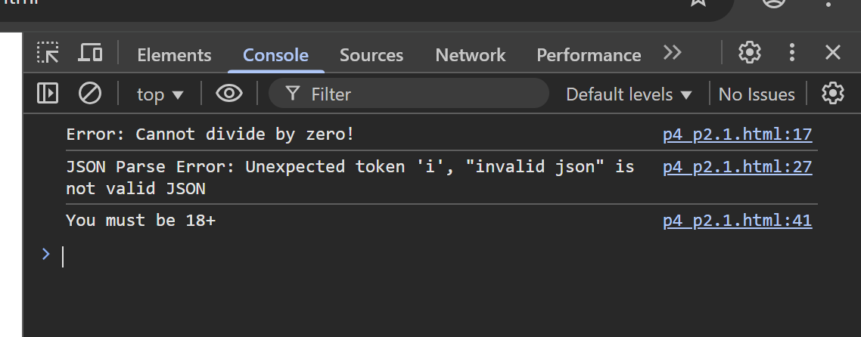
Example 4 – Using finally
try {
let fileOpen = true;
console.log("Opening file...");
// Simulate an error
throw new Error("File read error!");
console.log("Reading file..."); // this line will not run }
catch (err)
{
console.log("Error:", err.message);
}
finally
{
console.log("Closing file (cleanup)...");
} 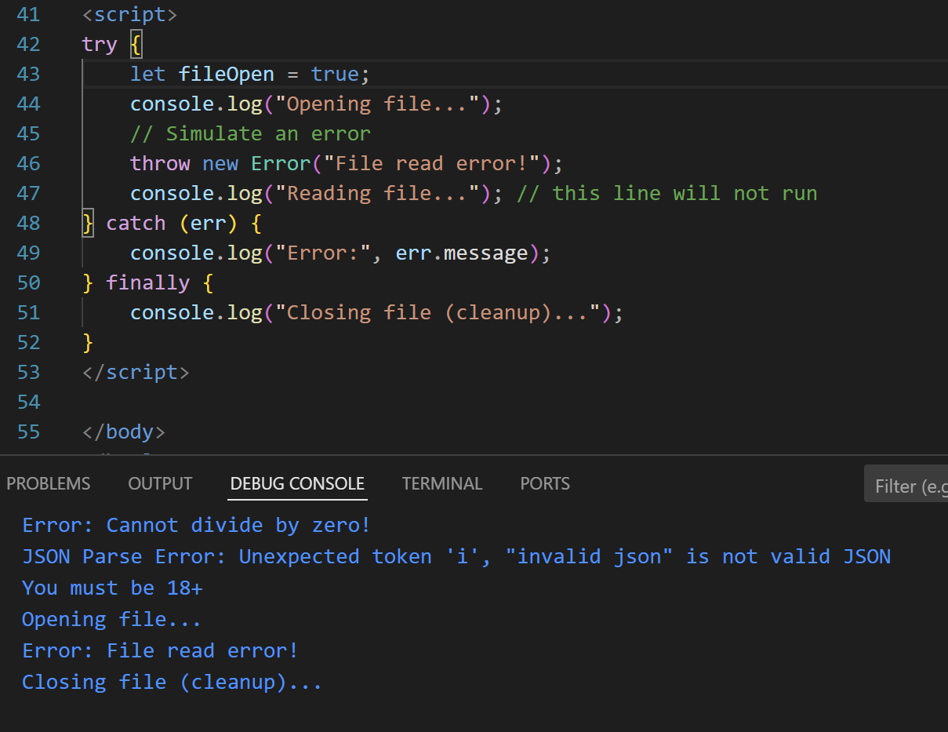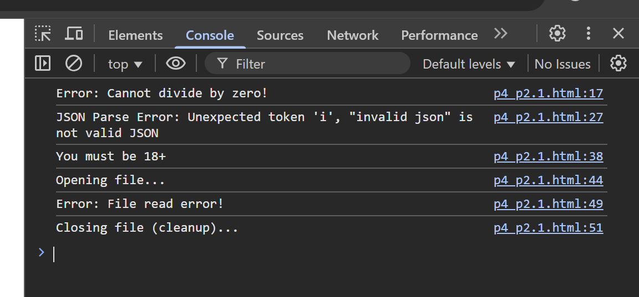
2. Reverse Number Function & Palindrome Check Logic:
● Convert the number to string.
● Reverse the string.
● Convert back to number.
● Compare with original.
Implementation:
function reverseNumber(num)
{
if (typeof num !== "number" || isNaN(num))
{
throw new Error("Invalid number input");
}
return parseInt(num.toString().split("").reverse().join("")); }
function isPalindrome(num) {
return num === reverseNumber(num);
}
try {
let num = 1221;
console.log("Reversed:", reverseNumber(num)); console.log("Is Palindrome:", isPalindrome(num)); } catch (err) {
console.log("Error:", err.message);
}
Examples:
console.log(isPalindrome(12321)); // true
console.log(isPalindrome(45654)); // true
console.log(isPalindrome(12345)); // false 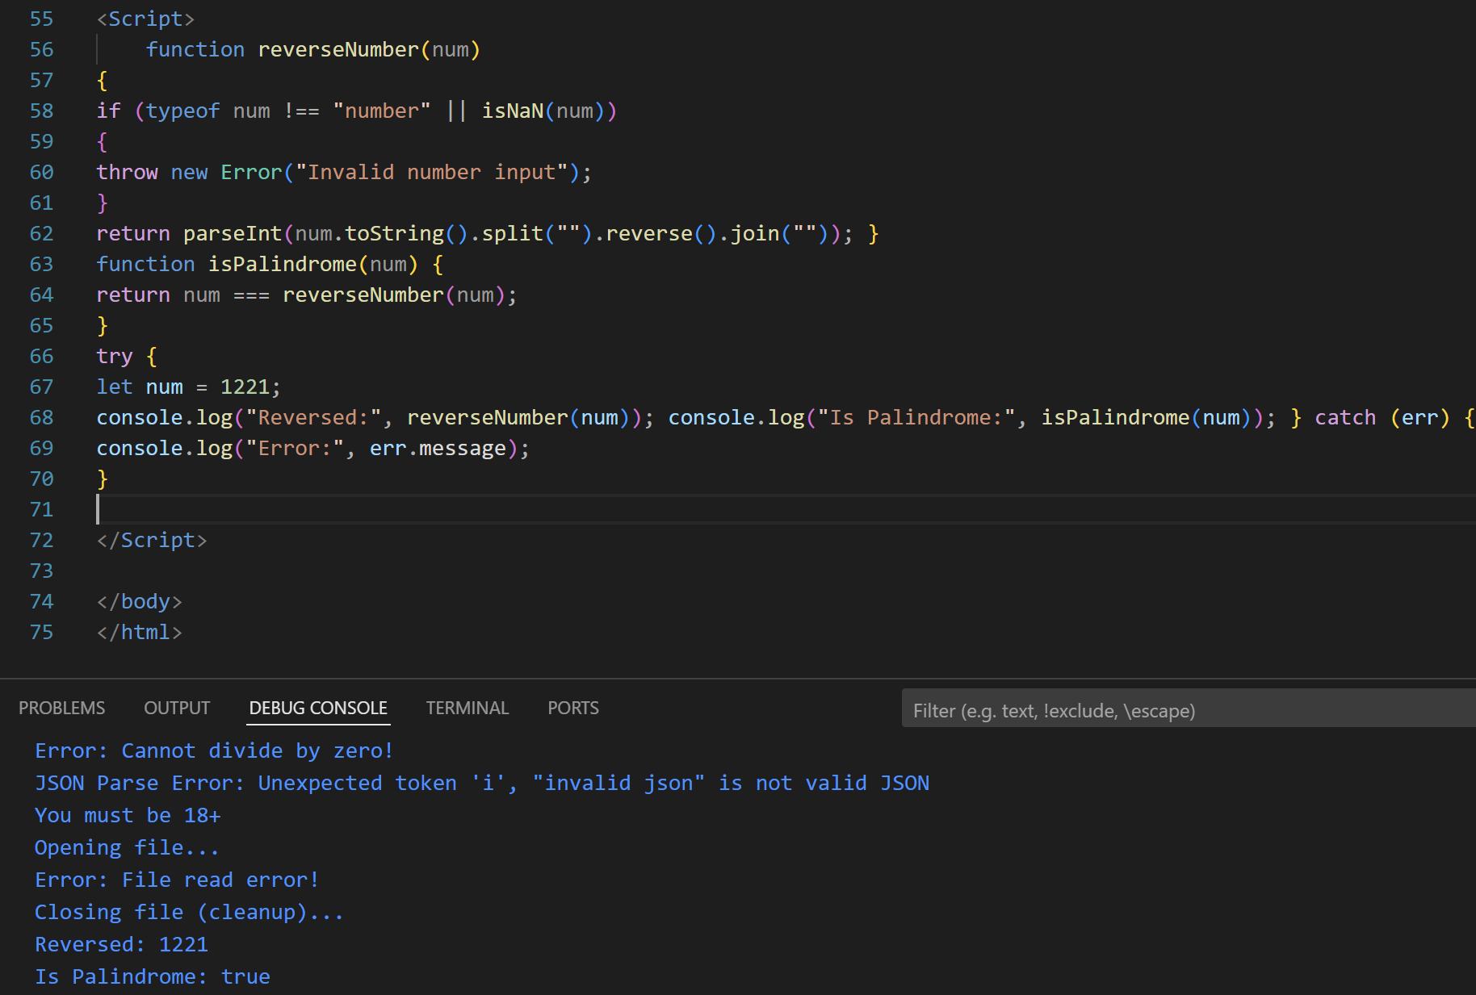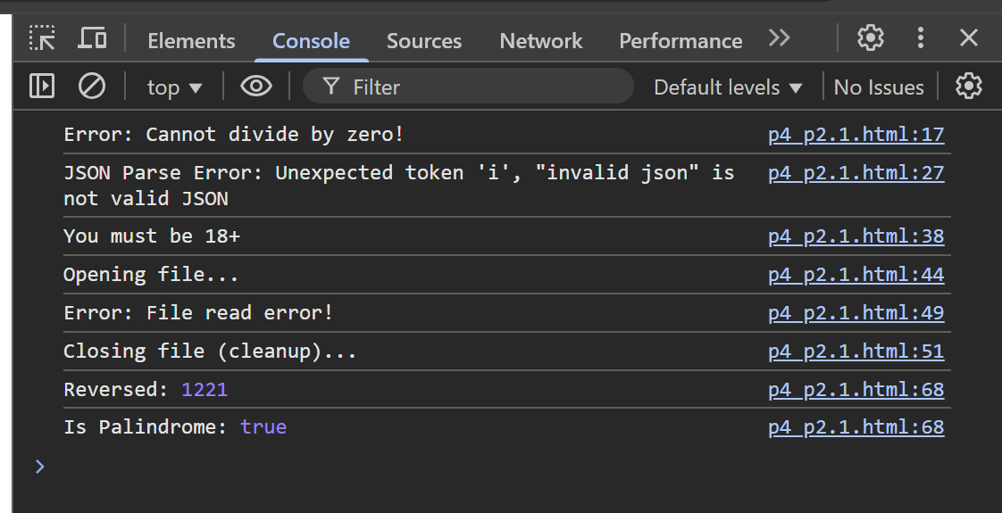
Student Tasks for Part 2
1. Modify reverseNumber to work for negative numbers as well.
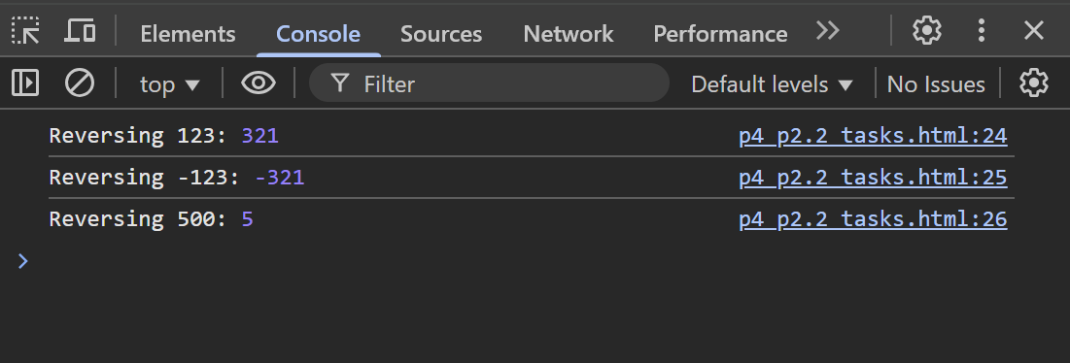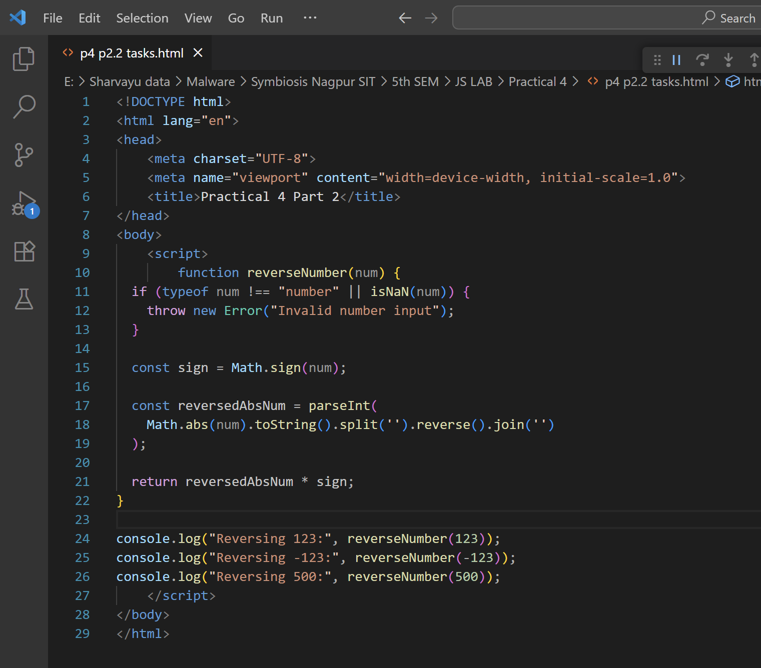
2. Write a program that takes user input (string) and checks if it’s a palindrome (word-based, not number).
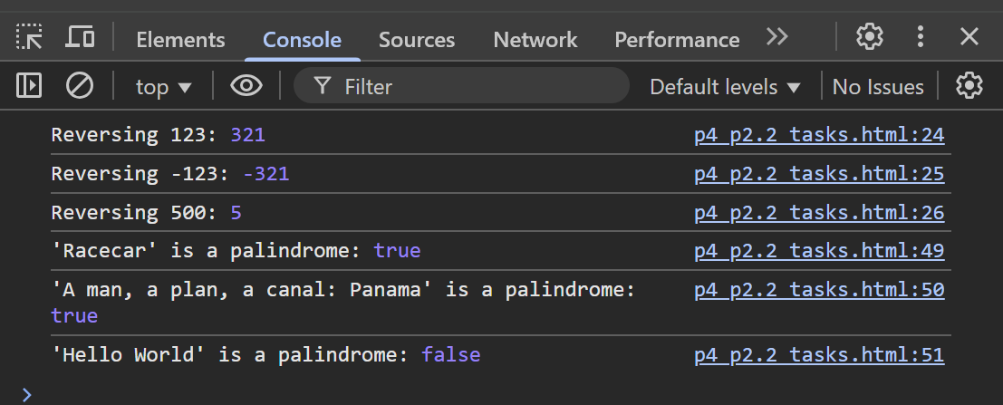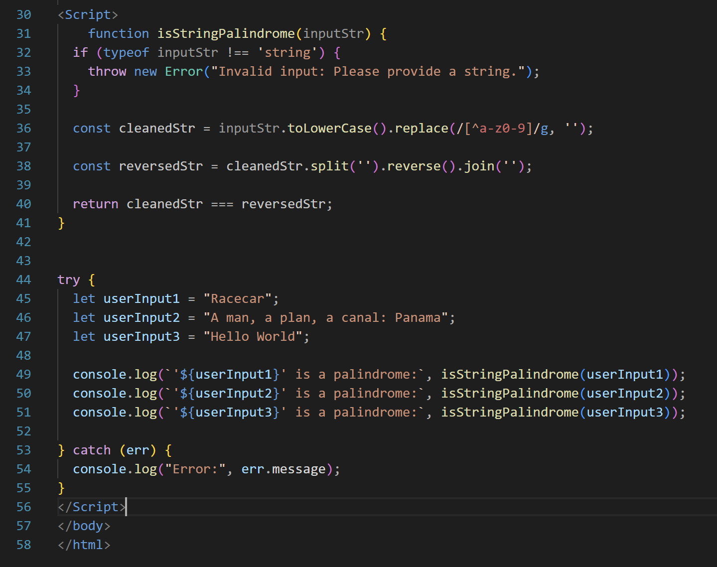
3. Use try...catch to handle invalid inputs for a square root function. 4. Create a function using arrow syntax that checks if a given number is prime, and handle invalid inputs with try...catch.